Lab Manual
Data Mining

By
Abdullah Azhar | 2023-BS-AI-150
Submitted to
Sir Arham
Bachelor of Science in Artificial Intelligence
DEPARTMENT OF COMPUTER SCIENCES

Table of Contents
Lab 1: Knime Introduction 3
Real World Problem 3
Dataset 3
Practical Objectives: 3
Procedure: 4
KPI Summary: 9

Lab 1: Knime Introduction

Real World Problem
A retail store has accumulated sales data across multiple product categories and needs a structured way to analyse its performance. The management requires a clear understanding of overall revenue, the average value of each order placed, which categories drive the most income, and which individual products are the highest earners. This lab uses KNIME to address these needs through a series of visual, node-based operations on a CSV dataset..

Dataset
The dataset is a Retail Sales CSV file containing one row per transaction. I
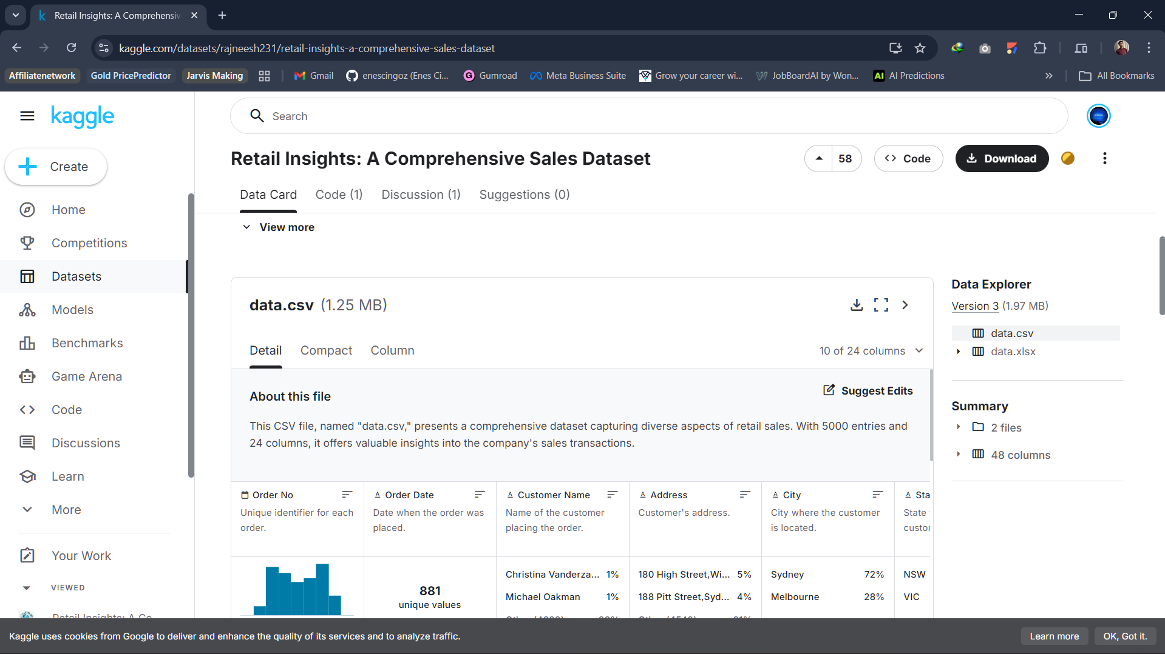

Practical Objectives:
By the end of this lab, students will have hands-on experience with the core features of KNIME Analytics Platform. Specifically, students will be able to:
- Import a CSV dataset into a KNIME workflow using the CSV Reader node.
- Inspect and correct column data types where necessary.
- Generate descriptive summary statistics to understand data distribution.
- Create a derived Revenue column using the Math Formula node.
- Compute four business KPIs using GroupBy and Sorter nodes.

Procedure:

Step 1. Create a New Workflow
Launch KNIME Analytics Platform. From the menu, go to File ,New , New KNIME Workflow. Name the workflow Retail Sales Analysis and click Finish. This creates a blank canvas where all nodes will be placed and connected.
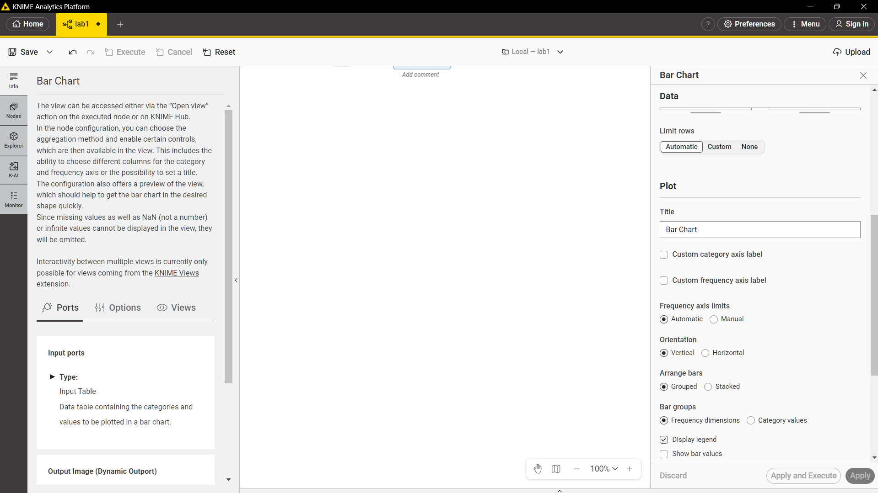
Step 2. Import the Dataset
Search for the CSV Reader node in the Node Repository panel on the left. Drag it onto the workflow canvas, then double-click it to open its settings. Click Browse and select the Retail Sales CSV file, then click OK. Right-click the node and select Execute. Once execution is complete, right-click again and choose View Table to confirm the data has loaded correctly.
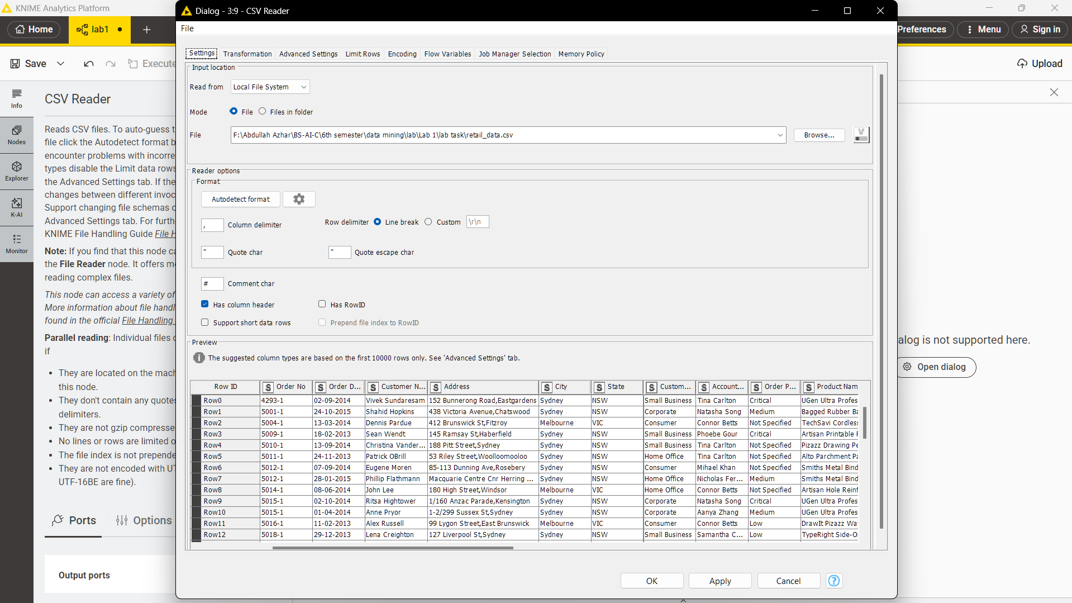
Step 3. Verify Data Types
After loading, inspect the column types shown in the CSV Reader output. The Quantity column must be an Integer, Price must be a Double, Order Date must be a Date type, and Category must be a String. If any column is incorrectly typed for instance, if Price is read as a String — apply the appropriate conversion node before proceeding. Use String to Number for numeric columns and String to Date&Time for the date column.
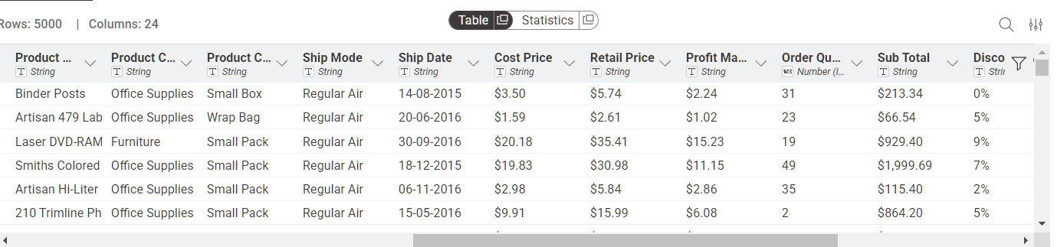
Step 4. Generate Summary Statistics
Add a Statistics node to the canvas and connect it to the output port of the CSV Reader. Execute it and view the result. The output shows the mean, minimum, maximum, standard deviation, and sum for each numeric column. This step provides an immediate snapshot of data distribution and helps identify any anomalies before analysis begins.
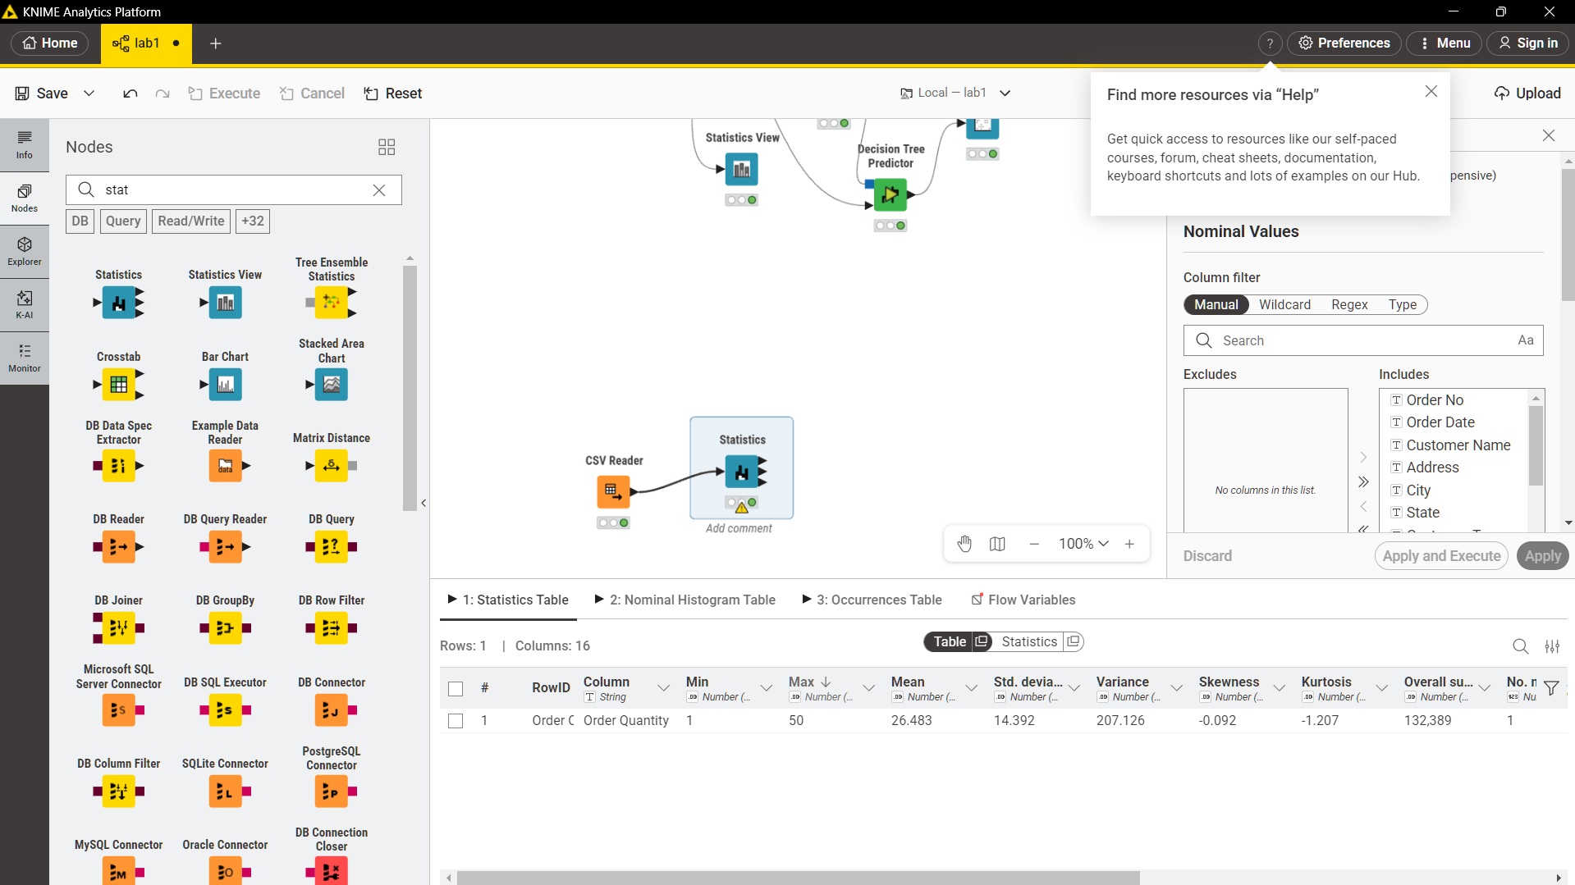

Step 5. Calculate the Revenue Column
Add a Math Formula node and connect it to the CSV Reader. Inside the node configuration, create a new column named Revenue using the formula:
$Quantity$ * $Price$
Execute the node. Each row in the output now contains the revenue value for that individual transaction, which will serve as the base for all KPI calculations.
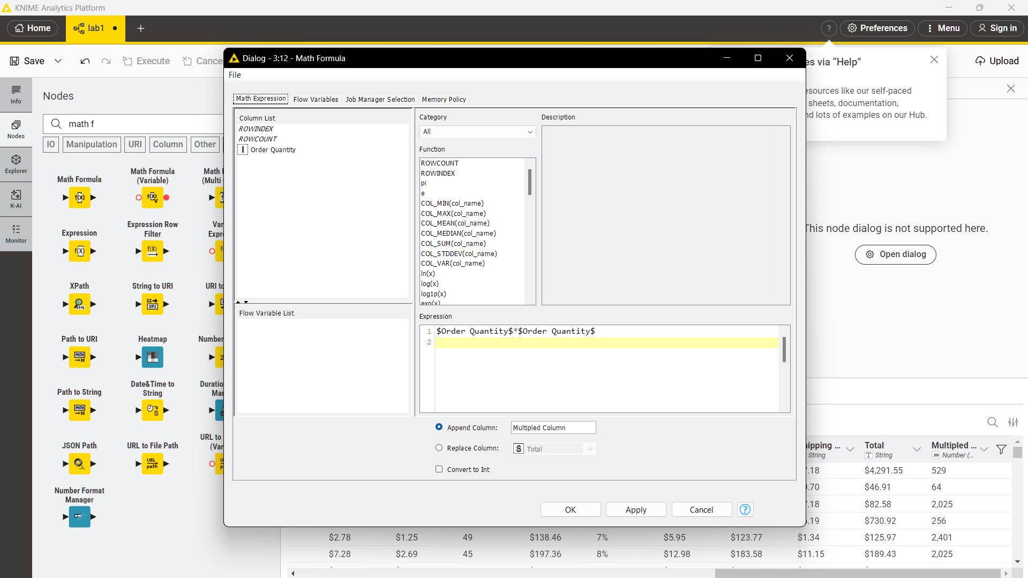

Step 6. Compute Business KPIs
All four KPIs are computed using combinations of GroupBy and Sorter nodes connected to the Math Formula output. The process for each is described below.
KPI 1 Total Revenue
Add a GroupBy node with no grouping column selected. In the Manual Aggregation tab, select the order quantity column and set the aggregation method to Sum. Execute the node. The single output row shows the total revenue across all transactions.
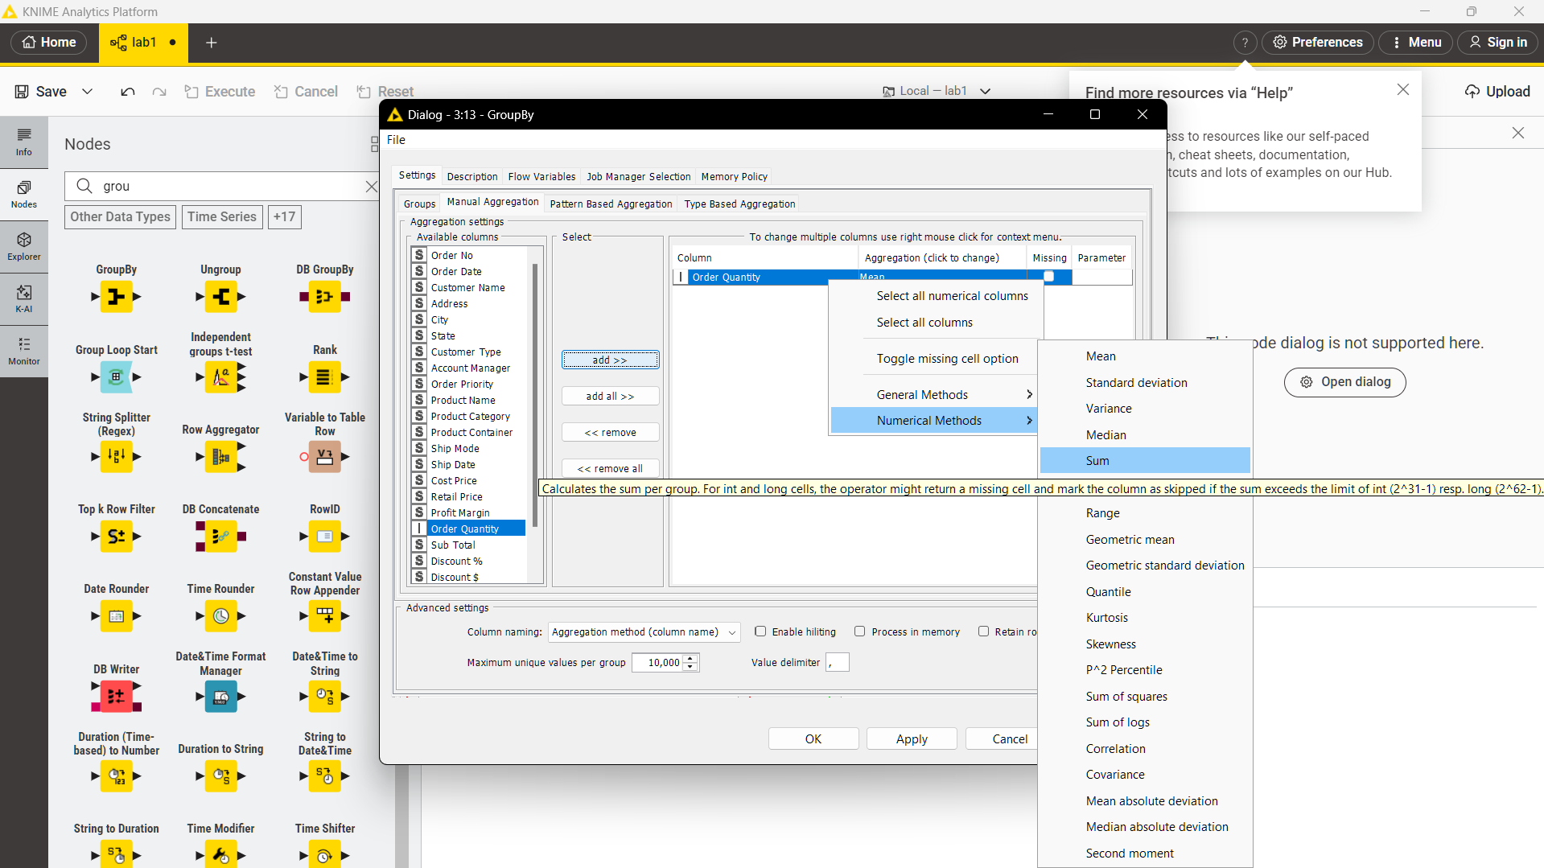
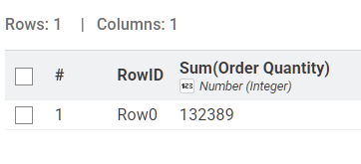

KPI 2 Average Order quantity
Add a GroupBy node and group by Order ID, aggregating Revenue using Sum. This produces the total revenue per order. Connect a second GroupBy node with no grouping column, aggregating the result using Mean. The output is the average revenue per order.
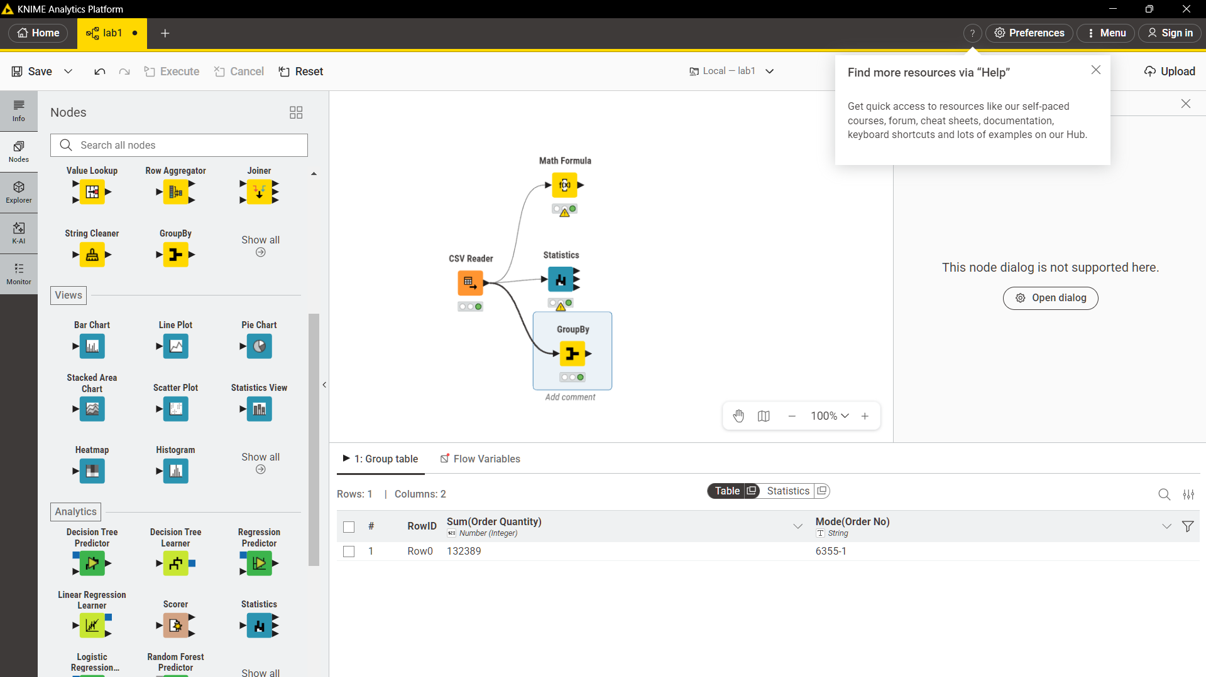

KPI 3 Category Revenue
Add a GroupBy node and group by the Category column, aggregating Revenue using Sum. Connect a Sorter node configured to sort by Revenue in descending order. The resulting table ranks each product category from highest to lowest earnings.
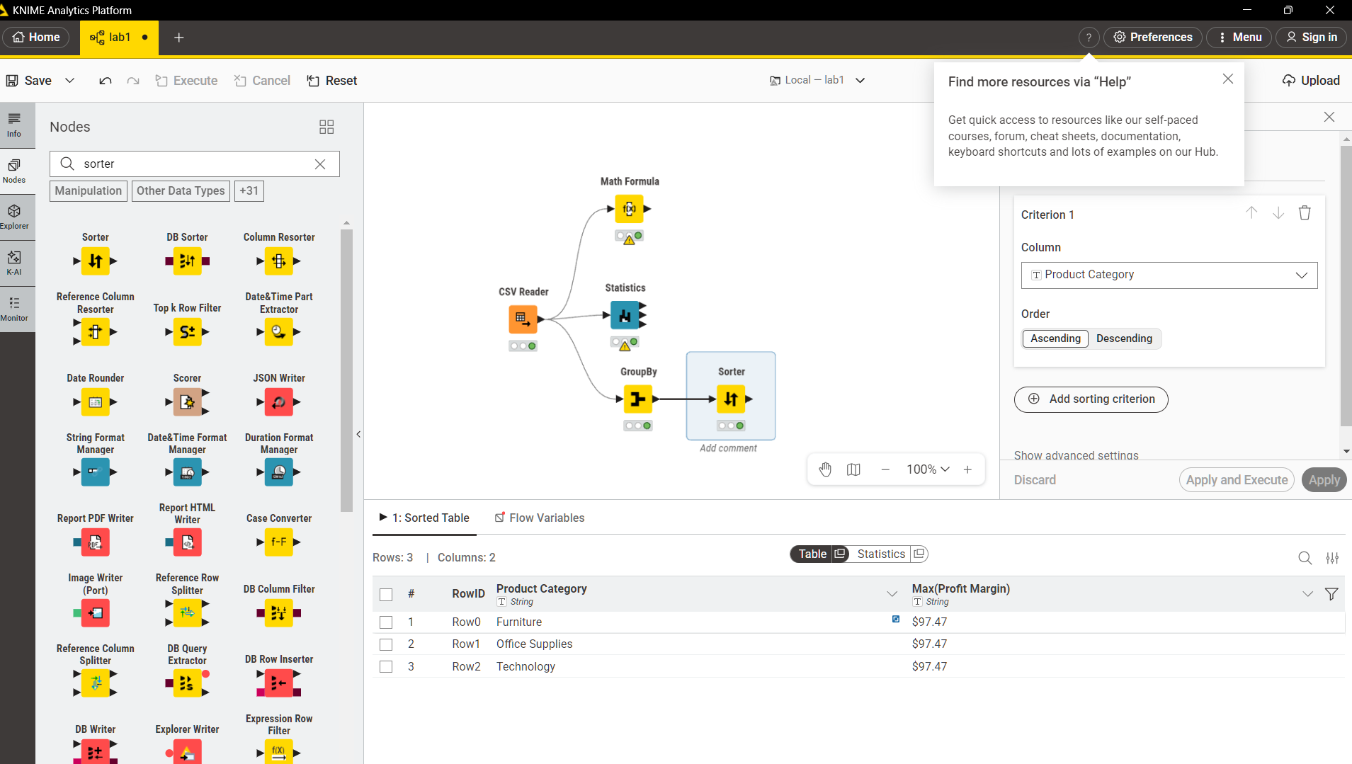
KPI 4 Top Products
Add a GroupBy node and group by Product Name, aggregating Revenue using Sum. Connect a Sorter node sorted by Revenue in descending order. The top rows of the output identify the highest revenue-generating products.
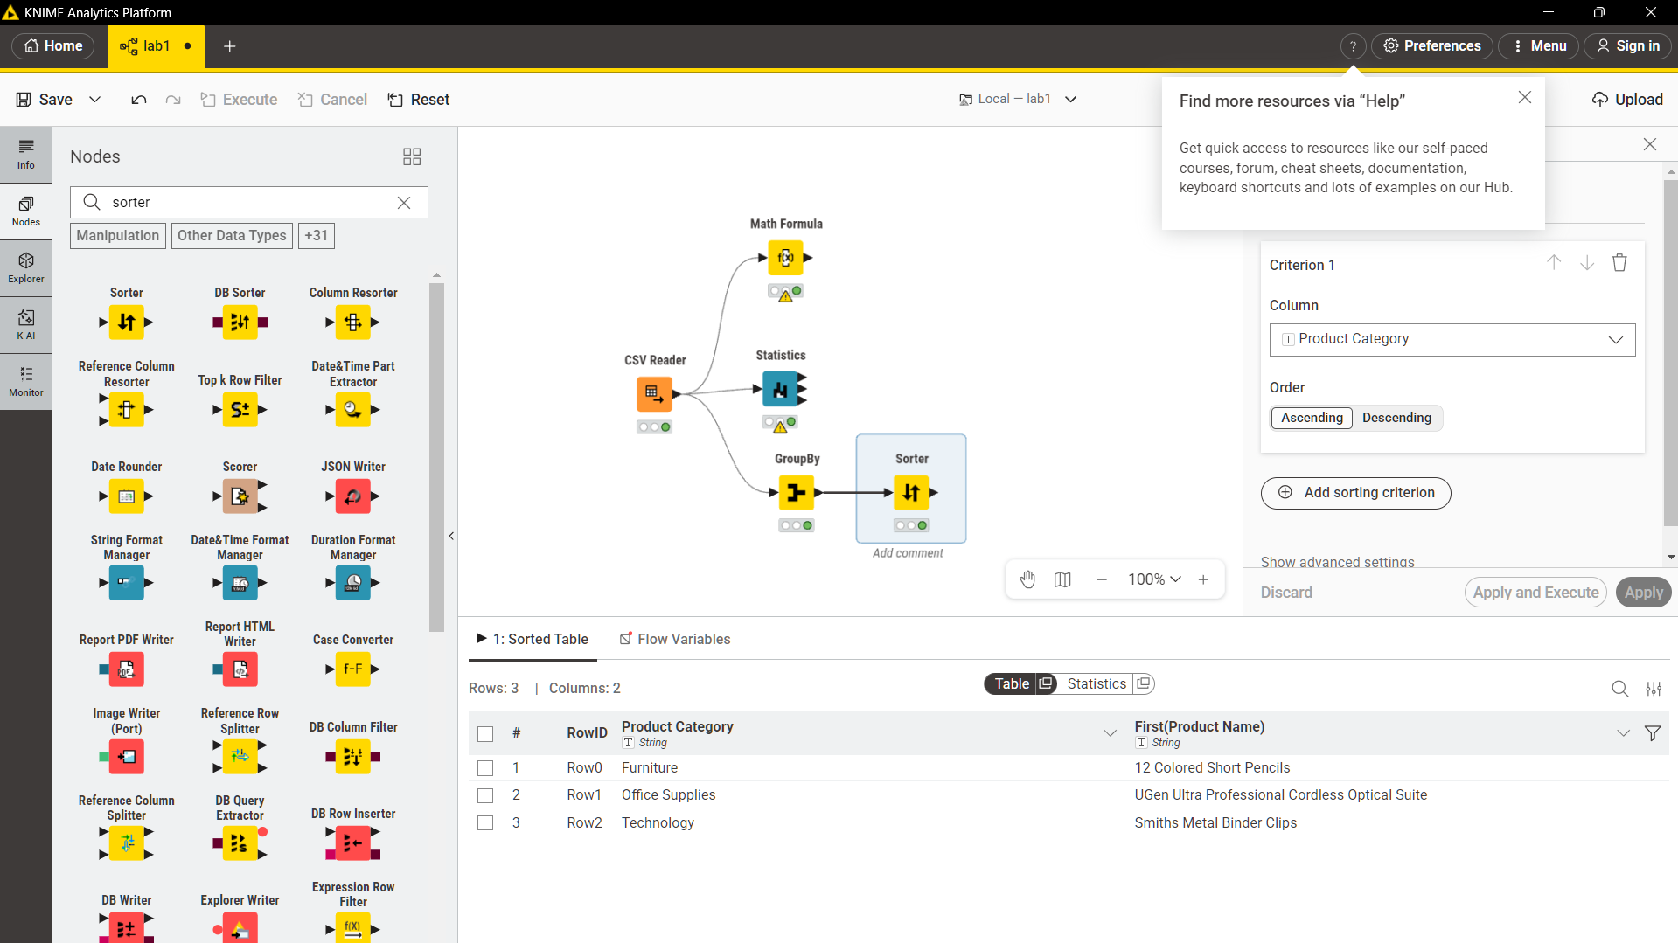

KPI Summary:

KPI | Method | KNIME Nodes Used
Total Revenue | Sum of (Quantity × Price) | Math Formula: GroupBy (Sum)
Average Order Value | Mean revenue per Order ID | GroupBy (Order ID) : GroupBy (Mean)
Category Revenue | Revenue grouped by Category | GroupBy (Category) : Sorter (Desc)
Top Products | Revenue grouped by Product Name | GroupBy (Product Name): Sorter (Desc)

